**Blynk Set up**

Step 1: Create an Account in Blynk

Step 2:

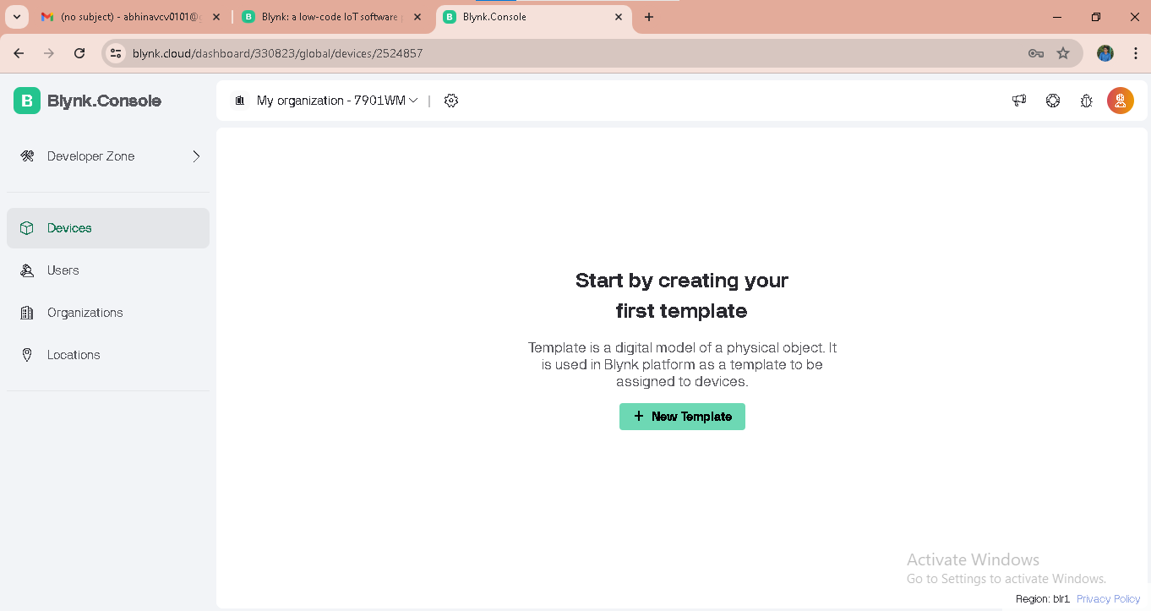

Click on New Template

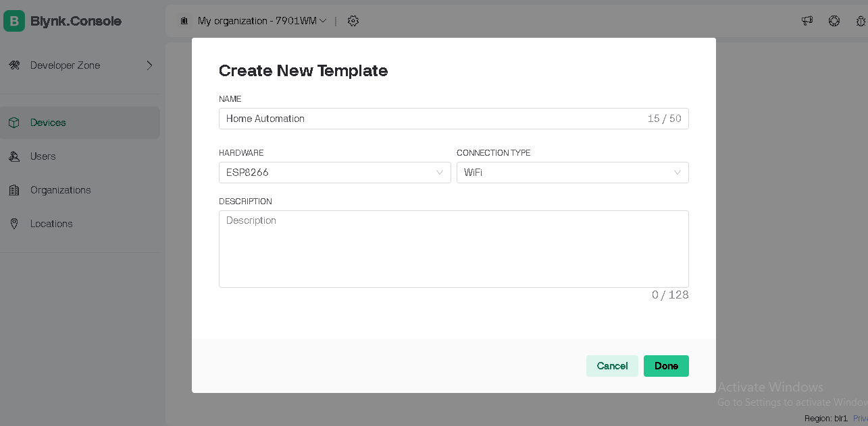

Step 3 -   
 Type Project name

Select Device as ESP8266

Connection Type – Wfi

Description – optional

Click Done

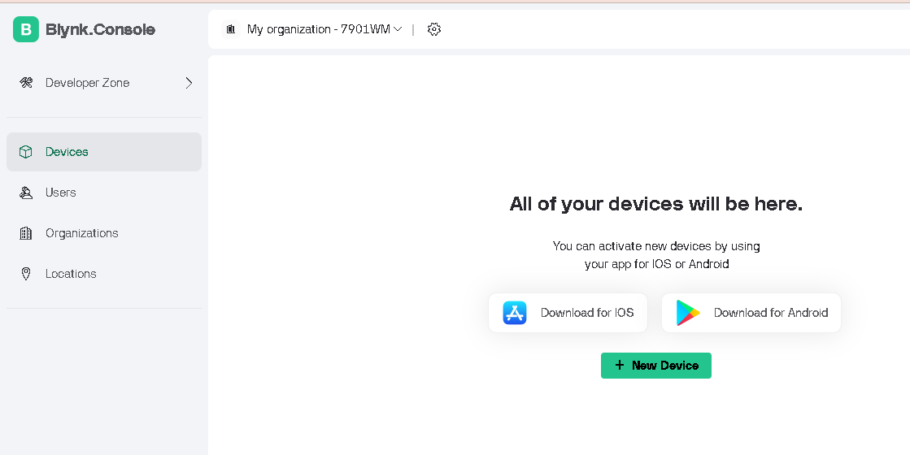

Click on Devices

Click on New Device

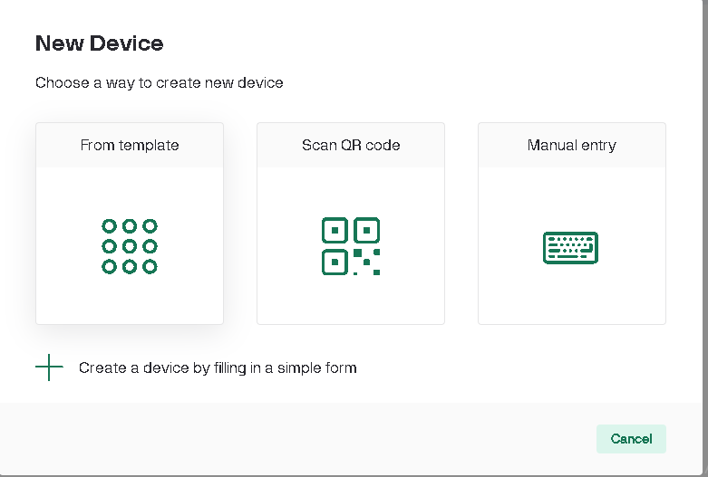

Click on From Template

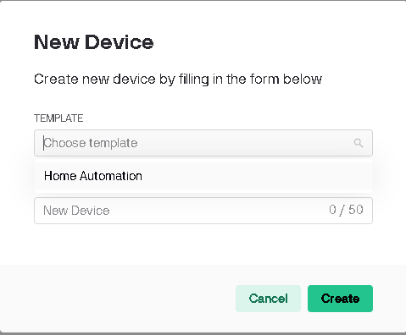

Click on chose template   
Click on Home Automation

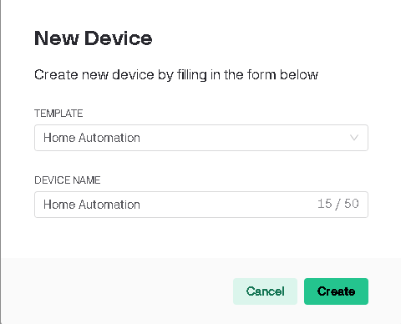

Click on Create

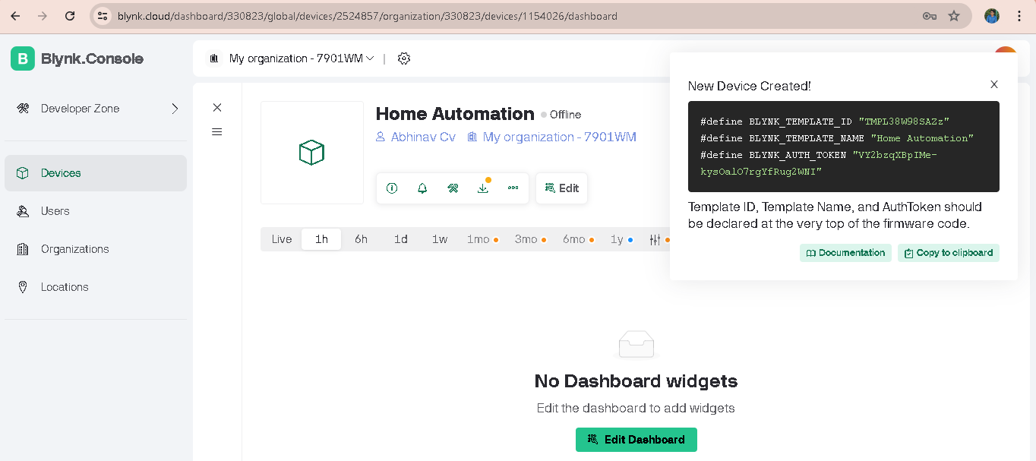 You can see Api and other header files in Right Corner

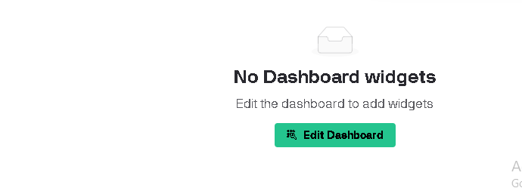

Click on edit Dashboard

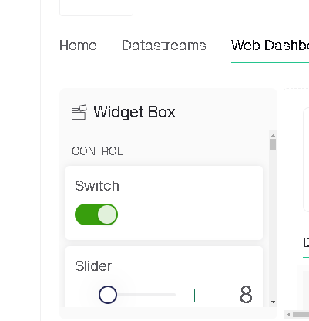

Select Switch widget

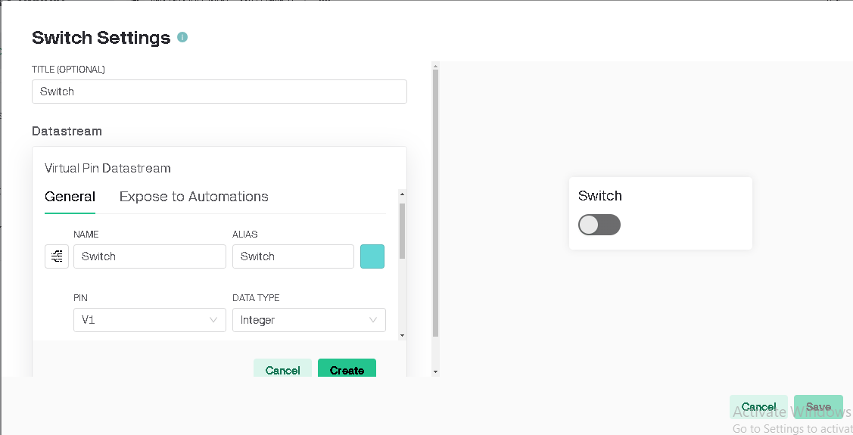

#define BLYNK_TEMPLATE_ID "TMPL38W98SAZz"

#define BLYNK_TEMPLATE_NAME "Home Automation"

#define BLYNK_AUTH_TOKEN "0gNVui8QgId926sVJwGx-oSxNobGe2X-"

